Solution to every third end-of-chapter problem
Basics of Engineering Economy, 2nd edition
Leland Blank and Anthony Tarquin

Chapter 3
Nominal and Effective Interest Rates

3.1 (a) Nom i/semi = 0.02*2 = 4% (b) Nom i/year = 0.02*4 = 8%
(c) Nom i/2 years = 0.02*8 = 16%

3.4 (a) year; (b) quarter; (c) day; (d) continuous (period length is zero); (e) hour

3.7 (a) r = 2% per quarter
(b) r = 2(2/3 quarter) = 1.33% per 2 months
(c) r = 2(8 quarters) = 16% per 2 years
(d) r = 2(4 quarters) = 8% per year
(e) r = 2(2 quarters) = 4% per semiannual period

3.10 (a) i/week = 6.8/26 = 0.262%; (b) effective

3.13 PP = day; CP = quarter

3.16 (a) Need effective i/quarter: i/quarter = 12%/4 = 3%

(b) Need effective i/semi: i/semi = (1 + 0.06/2)² -1
= 0.0609 (6.09%)

(c) Need effective i/year: i/year = (1 + 0.12/4)⁴ -1
= 0.1255 (12.55%)

3.19 In $ million units,
F = (54 +14 + 10)(F/P,1.5%,12)
= 78(1.1956)
= $93.2568 ($93,256,800)

3.22 F = 242,000(F/P,1.5%,48)
= 242,000(2.0435)
= $494,527

3.25 P = 190,000(P/F,2%,8) + 120,000(P/F,2%,16)
= 190,000(0.8535) + 120,000(0.7284)
= $249,573

3.28 F = 18,000(F/P,8%,6) + 26,000(F/P,8%,5) + 42,000(F/P,8%,4)
= 18,000(1.5869) + 26,000(1.4693) + 42,000(1.3605)
= $123,907
3.31 P = 51(100,000)(0.25)(P/A,0.5%,60)
= (1,275,000)(51.7256)
= $65,950,140

3.34 First find P; then convert to A

P = 40,000 + 40,000(P/A,12%,2) + 50,000(P/A,12%,3)(P/F,12%,2)
= 40,000 + 40,000(1.6901) + 50,000(2.4018)(0.7972)
= $203,340

A = 203,340(A/P,12%,5)
= 203,340(0.27741)
= $56,409

3.37 i/week = 0.25%
P = 2.99(P/A,0.25%,40)
= 2.99(38.0199)
= $113.68

3.40 P = 90(P/A,3%,12) + 2.50(P/G,3%,12)
= 90(9.9540) + 2.50(51.2482)
= $1023.98

3.43 Find cost of treatments after one year, then monthly equivalent A over 5 years

Cost of treatment = 10,000(F/A,1%,12)
= 10,000(12.6825)
= $126,825

A = 126,825(A/P,1%,60)
= 126,825(0.02224)
= $2821 per month

3.46 i/quarter = (1 + 0.01)³ –1 = 3.03%

P = [140,000 + 140,000(0.20)](P/A,3.03%,12)
= 168,000(9.9362)
= $1,669,282

3.49 F = 9000(F/A,1%,24)
= 9000(26.9735)
= $242,762

3.52 (a) A = 48,000 – 2000(P/G,1.5%,7)(P/F,1.5%,5)(A/P,1.5%,12)
= 48,000 – 2000(19.4018)(0.9283)(0.09168)
= $44,698
(b)
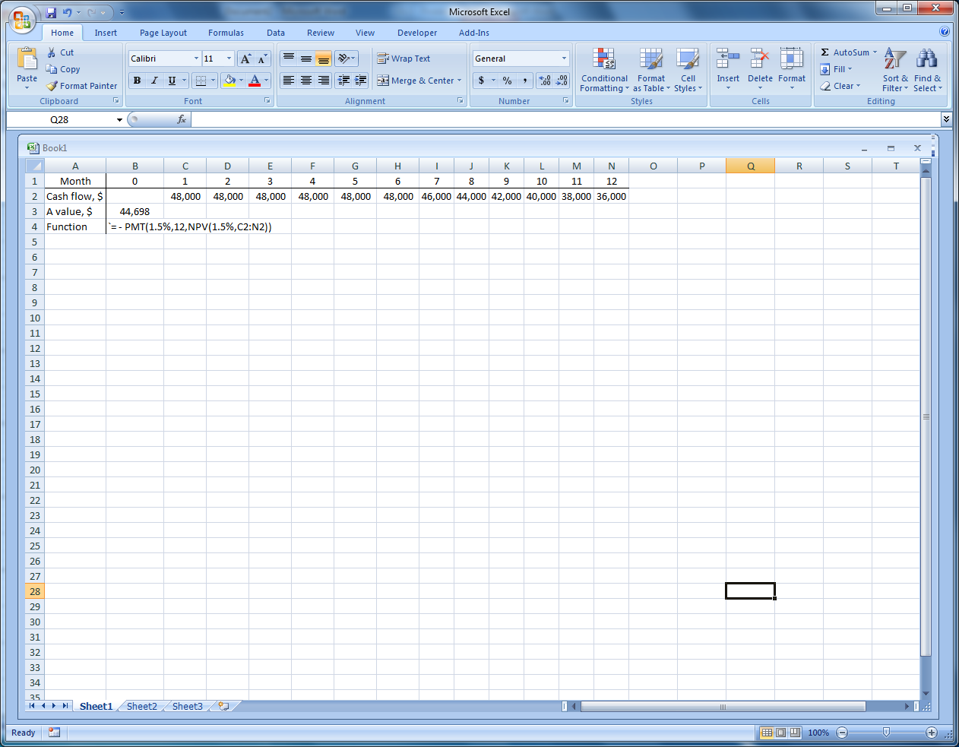

3.55 290,000(P/F,0.5%,48) = 4000(P/A,0.5%,48) + G(P/G,0.5%,48)
290,000(0.7871) = 4000(42.5803) + G(959.9188)
959.9188G = 57,938
G = $60.36

3.58 i = e^{0.0125} – 1 = 1.26% per month

F = 100,000(F/A,1.26%,24)
= 100,000{[1 + 0.0126)²⁴ –1]/0.0126}
= 100,000(27.8213)
= $2,782,130

3.61 A/3 months = 3(1500) = $4500
F = 4500(F/A,1.5%,20)
= 4500(23.1237)
= $104,057

3.64 Move chemical cost to end of interest period; find A

Chemical cost/month = 11(30) = $330
A = 1200(A/P,1%,48) + 330
= 1200(0.02633) + 330
= $361.60

3.67 Move cash flow to end of interest period (year); find P

Fuel savings = 800(0.50)(12) = $4800 per year
P = 4800(P/A,12%,3)
= 4800(2.4018)
= $11,529

3.70 Answer is (a)

3.73 P = 30(P/A,0.5%,60)
= $1552

Answer is (b)

3.76 PP > CP; must use i over PP of 1 year. Therefore, n = 7

Answer is (a)

